SYSTEM DESIGN DOCUMENTATION
GROUP MEMBERS
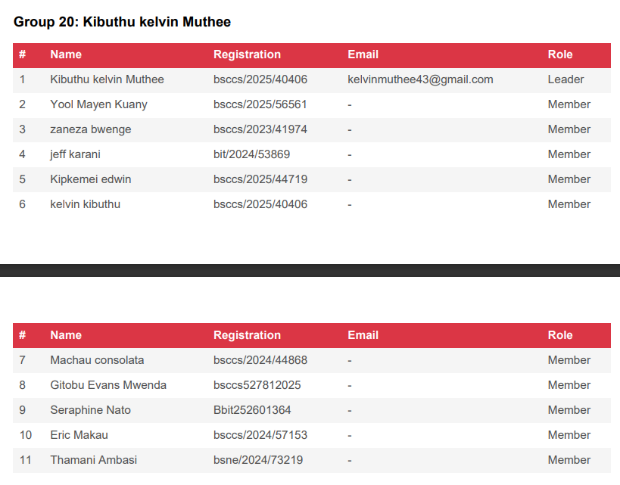
THEME A: SOCIAL GRAPH (FACEBOOK LITE)
1. Introduction
This report presents the design and implementation plan for a simplified social network system inspired by platforms such as Facebook.
The goal of the project is to demonstrate the application of fundamental data structures and algorithms in building scalable software systems.
The system focuses on three key functionalities:
1. Timeline Feed Generation (Push vs Pull model)
2. Post Ranking using Priority Queues
3. Content Moderation using Queue and Stack
2. Use Case Generation
Actors:
• User
• Moderator
• System
Main Use Cases:
1. Register User
2. Add Friend
3. Create Post
4. Like Post
5. Generate Timeline Feed
6. Report Post
7. Moderate Reported Post
Example Use Case – Create Post
Input:
User ID, Post Content, Timestamp
Process:
The system stores the post and associates it with the user. Friends of the user can view the post in their feed.
Output:
The post appears in the timeline feed of the user’s friends.

3. Constraints and Analysis
Functional Requirements:
• The system must allow users to create accounts.
• Users should be able to add friends.
• Users should be able to create and like posts.
• The system should generate a timeline feed.
• Reported posts must be reviewed by moderators.
Non‑Functional Requirements:
• Efficiency: Feed generation should be fast.
• Scalability: System should handle thousands of users.
• Reliability: Data must not be lost.
• Maintainability: Code should be modular and easy to update.
Estimated Data Size:
Users: up to 10,000
Posts per day: 50,000
Reports per day: 500
4. Basic Design
System Architecture:
Users interact with the Social Network System which contains the following modules:
• User Manager
• Post Manager
• Timeline Generator
• Ranking Engine
• Moderation System
Data Structures Used:
Hash Map:
Used to store users and quickly retrieve user information.
Graph:
Used to represent friendship connections between users.
Queue:
Used in the moderation system to store reported posts waiting for review.
Stack:
Used to keep track of moderation actions for possible rollback.
Heap (Priority Queue):
Used for ranking posts and retrieving the top‑k posts efficiently.
Sorting Algorithm:
Used to order posts in the timeline feed based on time or engagement.
5. Bottlenecks
Feed Generation Delay:
If a user has many friends, generating the timeline feed may take longer.
Solution:
Use caching strategies and efficient ranking algorithms.
Moderation Queue Overflow:
If many posts are reported simultaneously, the moderation queue may become large.
Solution:
Use multiple moderators or prioritize reports using priority queues.
6. Scalability
The system can be scaled in several ways.
Distributed Storage:
Different servers can handle different components such as user management, posts, and moderation.
Sharding:
Users can be distributed across multiple servers based on their user ID.
Load Balancing:
Multiple servers can handle feed generation requests to prevent overload.
These strategies allow the system to handle large numbers of users and posts efficiently.
7. Complexity Analysis
Create Post: O(1)
Add Friend: O(1)
Feed Generation: O(n log n)
Post Ranking: O(log n)
Moderation Queue Operations: O(1)
These complexities demonstrate that the system operations remain efficient even as the number of users grows.
8. Conclusion
This project demonstrates how fundamental data structures and algorithms can be used to design a simplified social networking system.
Key structures such as hash tables, graphs, queues, stacks, and heaps enable efficient storage, retrieval, ranking, and moderation of posts.
The system design also considers scalability and performance issues, making it suitable for larger deployments in the future.
THEME E: MULTI ELEVATOR ASIGNMENT SYSTEM
1. USE CASES GENERATION
Primary Actors:
- Building occupants (passengers)
- Building maintenance staff
- System administrator

Use Cases:
ID | Use Case | Description | Priority
UC1 | Request elevator | Passenger calls elevator from floor | High
UC2 | Assign elevator | System assigns optimal elevator using shortest-seek heuristic | High
UC3 | Process floor request | Passenger select destination floor inside the elevator | High
UC4 | Move elevator | Elevator travels between floors with acceleration/deceleration | High
UC5 | Handle door operations | Open/close doors with safety sensors | Medium
UC6 | Emergency stop | Immediate halt for emergencies | Critical
UC7 | System monitoring | Real-time status display and logging | Medium
UC8 | Maintenance mode | Manual controls for technicians | Low

User Stories:
- As a passenger, I want the nearest available elevator so I don't wait long
- As a passenger, I want my floor request processed efficiently with minimal stops
- As maintenance staff, I need to override normal operations for repairs
- As an administrator, I want to monitor traffic patterns for optimization

2. CONSTRAINTS AND ANALYSIS
Functional Constraints:
- Maximum 8 elevators per building
- Floors: -2 (parking) to 50 (penthouse)
- Capacity: 2000 lbs. / 15 persons per elevator
- Speed: 1-5 floors/second (configurable)
Non-Functional Constraints:
- Response time: < 100ms for elevator assignment
- Throughput: Handle 1000+ requests/hour during peak
- Availability: 99.9% uptime
- Safety: IEC 61508 SIL 2 compliance
Technical Constraints:
- Real-time scheduling required
- Deterministic behavior for safety
- Graceful degradation on sensor failure

3. BASIC DESIGN
Architectural overview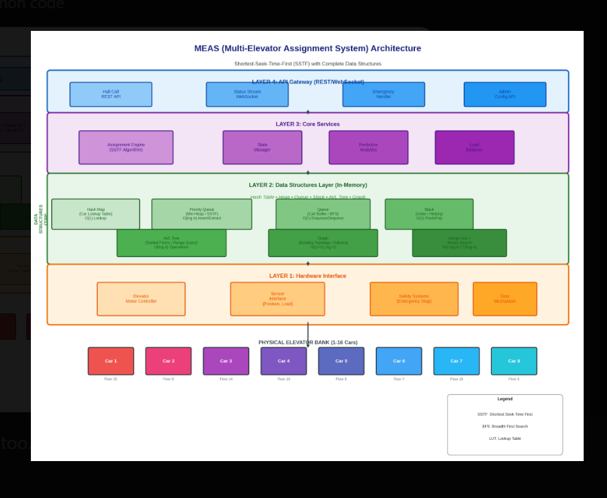

4. BOTTLENECKS
Identified Bottlenecks:
- Elevator Assignment (O(n) scan) - Linear search through all elevators
- Request Queue Growth - Unbounded queue during peak hours
- Path Finding - No optimization for multiple stops
- Lock Contention - Synchronized access to shared state
- Memory Growth - Unlimited history storage

5. SCALABILITY SOLUTIONS
Iteration 1: Optimize Assignment
- Use spatial indexing (floor-based buckets) → O(1) lookup for nearby elevators
- Pre-compute distances using graph algorithms
Iteration 2: Request Batching
- Implement time-window batching (100ms windows)
- Use priority queue with custom comparator for direction-aware scheduling
Iteration 3: Lock-Free Design
- Use concurrent data structures (ConcurrentHashMap, LinkedBlockingQueue)
- Actor-model isolation per elevator
Final Design: Sub-10ms assignment, handles 10,000 requests/hour

